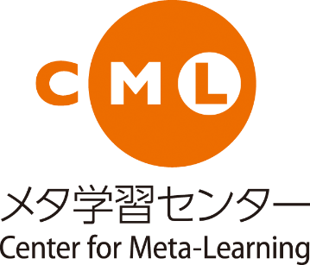
Future University Hakodate
Center for Meta-Learning
AY2016-2017 Activity Report
Think reflectively. Act collaboratively. Design the future.
Contents

AY2016-2017 CML Committee Members ・・・・・・・・・・・・・・・・・・・・・・・・・・・・・・・・・・・・・・・・・・・・・・・ 02

AY2016-2017 CML Activity Report
1. Foundation for Meta-Learning
1-1. CML Orientation ・・・・・・・・・・・・・・・・・・・・・・・・・・・・・・・・・・・・・・・・・・・・・・・・・・ 04
1-2. Meta-Learning Lab ・・・・・・・・・・・・・・・・・・・・・・・・・・・・・・・・・・・・・・・・・・・・・・・・・・・ 06
2. Preparatory Education
2-1. Preparatory Education in English ・・・・・・・・・・・・・・・・・・・・・・・・・・・・・・・・・・・・・・ 07
2-2. Preparatory Education in Math ・・・・・・・・・・・・・・・・・・・・・・・・・・・・・・・・・・・・・・・・・ 09
3. Supplementary Education
3-1. Supplementary Lecture in Math （MathⅡB, MathⅢ） ・・・・・・・・・・・・・・・・・・・・・・ 11
3-2. Connections Café ・・・・・・・・・・・・・・・・・・・・・・・・・・・・・・・・・・・・・・・・・・・・・・・・・・・・ 12
4. Professional Development：Workshop on lesson support tools “Basic & useful usage of HOPE / manaba”・・ 14

AY2016-2017 CML Committee Members

Department (Course) | Name
Chair of CML | Keiji Hirata (Professor)
Center for Meta-Learning | Mio Tsubakimoto（Associate professor）
 | Atsuko Tominaga（Associate professor）
 | Michiko Nakamura（Associate professor）
 | Smith Adam（Associate professor）
 | Rivers Damian（Associate professor）
Communication Group | Andrew Johnson（Associate professor）
 | Dominic Kasujja Bagenda（Associate professor）
 | Michael Vallance (Professor)
 | Peter Ruthven-Stuart （Associate professor）
Information Design Course | Yoshinari Takekawa (Associate Professor)
Advanced ICT Course | Kei Ito（Associate professor）
Intelligence Systems Course | Yasuyuki Sumi (Professor)
Complex Systems Course | Kiyohito Nagano（Associate professor）
General Affairs of CML | Education Affairs Department (University Office)
CML Coordinator | Lisa Takahashi

AY2016-2017 CML Activity Report

1. Foundation for Meta-Learning
1-1．CML Orientation

Program description
Starting from AY2013, we had the 4th annual CML orientation this year under the theme of “course selection”. Course selection is mandatory for the first year students by the end of the year. CML orientation aims to have students to be aware of the importance of essential elements of learning at the University (ownership of learning, self-directed learning，use of resources, informed decision-making, self-reflection, goal-setting, action-planning, collaboration, communication) and go through the process of making decision on selecting the course. CML orientation is held with the assistance of the faculty members and current students of the University on the last day of the Orientation Week, and all new students are expected to attend the orientation. During the orientation, the chair of each course and a few senior students introduce the course they belong to the first year students. Then, the new students are divided into groups and make a plan to collect information on each course. Based on the plan, a group of new students walk around the campus to interview the faculty members and the senior students. Afterwards, new students give each other a feedback and make a plan to achieve goals for the end of the year. It is believed that, through these activities, the 1st year students consider course selection as an important opportunity to make a decision on their future path based on their own will. It is contemplated that they learn necessary process to enroll the best-fit course and start their university life with a sense of direction.

Overview of AY2016-2017 activity
- Date: April 8, 2016, 9:00-15:30 (Place: Large lecture room)
- Target students: AY2016 first-year students
- Orientation staff: Mio Tsubakimoto, Atsuko Tominaga, Michiko Nakamura, Lisa Takahashi, Meta-lab tutors

- Schedule:
9:00 | Introduction  (introduction of the staff, what’s meta-learning? set up goals & schedules)
9:30 | An overview of FUN courses and panel discussion by course directors & senior students
10:55 | Informational resources for course selection
11:10 | Planning the information-gathering activity (a.k.a., campus ‘walk-around’ activity)
 | (lunch break)
13:00 | Information gathering (‘walk-around’) activity in group
14:40 | Fill out a worksheet and planning for the first year  (self-reflection, goal-setting, make a plan to achieve goals for the year)
15:00 | Review of CML orientation (including an introduction of meta-lab by tutors)
15:20 | Answering surveys

Outcomes
To understand students’ awareness of their experience and learning acquired from CML orientation, a survey was conducted online at the end of the orientation. It consisted of ten 4-point-scale Likert questions (from 1 as “disagree” to 4 as “agree”) followed by five additional multiple-choice questions and one open-ended question. A total of 224 students responded to the survey. Overall, students’ feedback was positive. 95% of students said they understood that they would have to make their own decisions when it comes to selecting a course (Q1.1). Similarly, a majority of students agreed that making their own decisions requires understanding the decision-making process (Q1.2) as well as knowing themselves (e.g., their own interests and strengths/weaknesses, Q1.8). Over 90% of students also reported that they were able to set their own goal for course selection a year ahead (Q1.9). The results of the Likert questions are shown below.

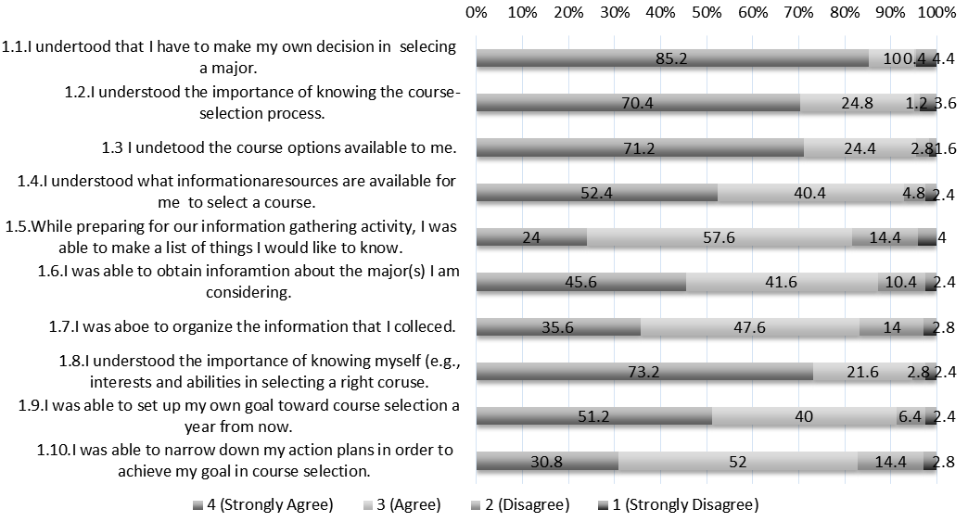

Reported by
Mio Tsubakimoto
Atsuko Tominaga
Michiko Nakamura
Lisa Takahashi

1-2. Meta-Learning Lab

Program description
Meta Learning Lab (hereinafter referred to as “MLL”) is an organization that supports extracurricular learning among FUN students aimed at the improvement of their study habits, consciousness/behavior towards learning methods, and basic learning skills. During AY2016-2017, 18 undergraduate and graduate students belong to MLL as a tutor. They have involved in extracurricular self-directed learning activities as a supporter, particularly on basic subjects for the 1st and the 2nd year students.

Overview of AY2016-2017 tutoring sessions
Number of tutoring sessions and maximum number of tutees accepted for the 1st and the 2nd semesters in 2016-2017 are as follows.
- 1st semester, 2016・・・Tutoring sessions：19 slots/week, Maximum number of tutees accepted：52/week
- 2nd semester, 2016・・・Tutoring sessions：19 slots/week, Maximum number of tutees accepted：32/week

Outcomes
Number of tutoring sessions and the level of tutees’ satisfaction
In AY 2016-2017, 235 tutoring sessions were implemented, 52 sessions less than the previous academic year. Tutoring sessions was held more often in the 1st semester (210 sessions) than the 2nd semester (25 sessions), because MLL emphasized on the linkage with the class titled “Introduction to Information Expression” that is a required subject for the 1st year students in the field of Programming. 76% of the concerns brought by the tutees were on programming-related subjects.

Figure 1 shows the results of the questionnaire filled out by tutees after the tutoring sessions. The most satisfactory items are questions 1, 2, and 3. More than 85-90% of the tutees answered “strongly agree” and more than 14-30% of them responded “agree” to these questions. The level of satisfaction on Question 4 is relatively low, but the total of the answers “strongly agree” and “agree” are 97%. This can be said that the tutees’ satisfaction on problem-solving is generally fulfilled. Compared with other questions, the level of satisfaction on questions 5 and 6 are not high enough, but like question 4, the response “(strongly) disagree” is less than 4%. It can be said that most tutees receive hints from tutors on learning skills. 80% of the tutees answer “strongly agree” and 20% responded “agree” to Question 7 concerning the achievement of MLL’s mission. It can be understood that 100% of the tutees were satisfied with the learning support provided by MLL, and it meets the tutees’ expectations.
Figure 1 Result of questionnaire by tutees (AY 2016-2017 / 235 responses, Collection rate: 100%)
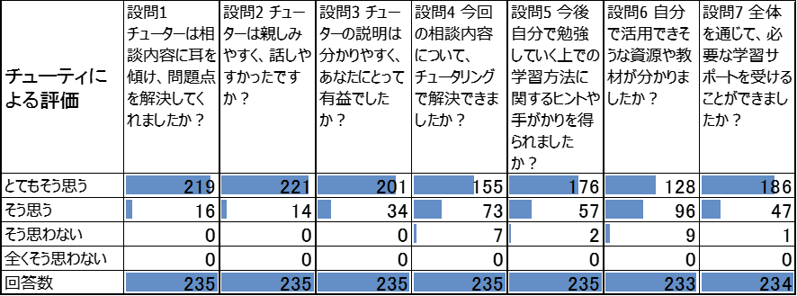

Reported by
Mio Tsubakimoto
Michiko Nakamura
Atsuko Tominaga
Lisa Takahashi
2. Preparatory Education
2-1． Preparatory Education in English

Program description
The Pre-enrolment English course is made available for students who have successfully taken the Admissions Office (AO) or Suisen entrance exams. Its primary aim is to help students maintain their English language skills in the four or five months between the exams and the start of lectures. Because it is an online course, it also enables students to experience e-learning, have asynchronous communication with classmates and learn about the university. The course consists of a mixture of communicative and individual study activities. Rather than provide students with study material that they passively work through individually, we have attempted to create an environment in which students make their own content in self-introduction and other discussion forums. They can interact with and learn from each other by reading or responding to forum posts.

Overview of AY2016-2017 activity
The 2017 course consisted of the following:
- a self-introduction forum,
- discussion forums and mini-surveys for 13 topics, which were designed to encourage both communication and reflection,
- an Oxford Bookworm graded reader "The Coldest Place on Earth", with online comprehension quizzes,
- access to the English Foundations course, where students can study grammar,
- an online exchange with 2016 Communication 4 students, entitled "A Day in the Life of FUN Students", and
- a series of informative PDFs about the FUN campus and facilities.

Explanations and descriptions in the course were provided in both English and Japanese.

In late December students were sent a description of the course and login instructions. They were advised to access it for at least two hours a week. In late January the book was sent to the students, and an explanation of the course was sent to their homeroom teachers.

Students accessed the course until early April. During Orientation Week a brief event was held in which an overview of the course was given and the students could meet each other for the first time as participants. They also completed a survey which asked for their opinions of and suggestions for the course.

Outcomes
- 98 students were enrolled in the course
- All but two students accessed the course
- 21 students accessed the course on average once a week
- The median access rate was (on average) once a fortnight
- 12 students accessed and attempted quizzes in the English Foundations course

While it is impossible to measure the time students spent reading the book that they received, there was clearly a wide range of access rates to the Moodle course (see Figure below). Some low-access students justified this with the response that they were studying English in other ways. While this may be a desirable situation in terms of their English language skills, they missed the other opportunities that the course offered. Other responses relate to access to a computer. In recent years the use of smartphones and smart devices has greatly increased, with nearly half of the students primarily using a smart device to access the course in 2017. In recognising this, the course has been modified to be more compatible with small screens.

Another reason given by students for not accessing the course more was not knowing what to do once there, in spite of clear bilingual explanations. This can be considered one of the main challenges of the course: encouraging students to communicate in English with people they have never met in an unfamiliar online environment. There is no way to force students to access the course. From 2016 course material has been sent to students' high school teachers, and while the number of students who accessed the course has increased, access rates have not changed greatly.

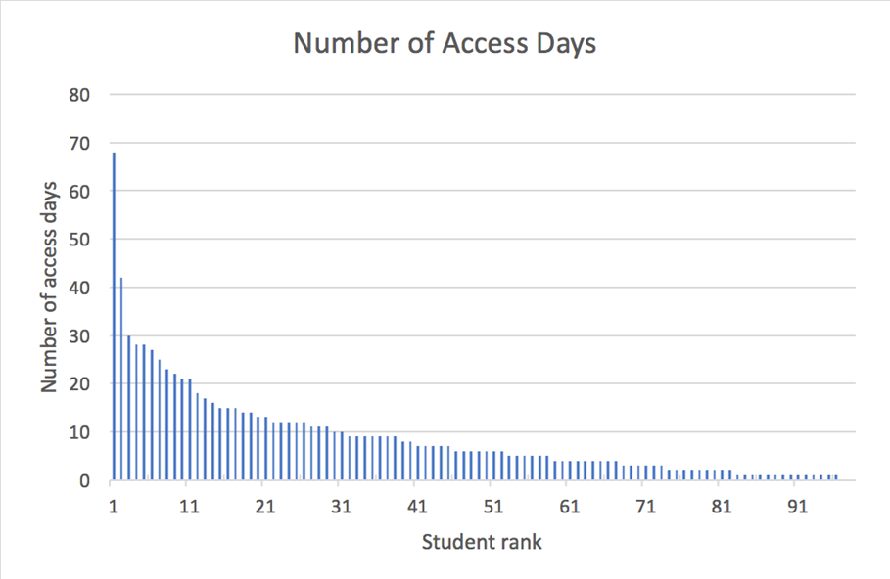

On the whole, students responded positively to the course, and reported enjoying the chance to study English and to experience e-learning. They would recommend the course to future students, however suggested that more offline activities be provided (in addition to the book). We will consider this when planning the 2018 course.

Reported by
Adam Smith

2-2. Preparatory Education in Math

Program description
The basic skills of math are one of the fundamental abilities we require of students who wish to enter FUN as a single-faculty university with the School of Systems Information Science. We expect incoming students to have knowledge of high school mathⅢ. Therefore, we give applicants basic questions of Math III as optional questions of the 1st phase entrance examination, and such admission policy is open to the public. However, many successful applicants of 1st phase entrance examination have not studied mathⅢ(especially of differential and integral equations) sufficiently at high school. Among successful applicants of AO examination or Examination for Admission on Recommendation, it is predicted that those who have not studied mathⅡand math B sufficiently will have difficulty in following the regular university curriculum after their entrance. Given this situation, Preparatory Education in Math has been carried out for such entrants of AO examination or Examination for Admission on Recommendation under the following objectives.
- Have students study math continuously after they pass the entrance exam.
- Have students be aware that the University considers math ability is essential for all students.

Overview of AY 2016-2017 activity
Schedule and objectives of assignments
① Assignments No.1
- Schedule: Assignment No.1 was sent on December 20 and due on January 16 (Assignment No.1 will be returned to students with the assignment No.2)
- Contents: Actual questions used for AO examination or Examination for Admission on Recommendation
- Aim: We expect students to go back to the basis of learning attitude by confirming what they do and do not understand about basic concept of math so that the problem is not left unclear. Adding to this, we emphasize the importance of writing the answer with clear words for readers.
② Assignment No.2
- Schedule: Assignment No.2 was sent on February 8 and due on February 27 (Assignment No.2 will be returned with the assignment No.3)
- Contents: Preparation for taking a class of “Analysis I”
- Aim: By experiencing actual FUN’s lecture contents, we expect students to realize the contents of high-school math is also important for the University. Compared with general entrance exam entrants, entrants of AO examination or Examination for Admission on Recommendation spend less amount of time studying in math. Students are expected to brace for studying at the University by providing a glimpse into the university-level math.
③ Assignment No.3
- Schedule: Assignment No. 3 was send on March 7. ※ The answers of assignment No.3 will be posted on the website.
- Contents: Math questions on the 1st phase entrance examinations of FUN
- Aim: The questions on the 1st phase entrance examinations are more difficult than those from AO examination or Examination for Admission on Recommendation. We expect entrants of AO examination or Examination for Admission on Recommendation to know their current math ability by solving the questions of the 1st phase entrance examination, and notice that their classmates will be the ones who passed the 1st phase entrance examination. We expect entrants of AO examination or Examination for Admission on Recommendation to review high school math again during the spring vacation, so that they can overcome their lack of ability and catch up with the math class after they enter the University.

Outcomes
The contents and the schedule of the three assignments are almost the same as last year’s. The number of registrants this year is 98 (/98). The answer sheets of assignment No.1 and No.2 were submitted from all 98 registrants and 96(/98) registrants respectively. We created the Website to support the registrants and post the materials for study in Math. 94(/98) registrants have accessed the website.

Reported by
Seiji Nagano

3-1. Supplementary Lecture for Math (MathIIB, MathIII)

Program description
As supplementary lectures for Analysis I and Analysis II, which are compulsory subjects of 1st year students, we carried out exercise style lectures of Math III and Math IIB. These lectures have been offered to students for more than ten years.

Overview of AY 2016-2017 activity
- Math III supplementary lecture
Objective: Open for all students who take Analysis I & II
Period: 8 times from Maｙ to July, 7 times from October to November (one and a half hours per lecture)
Venue: R791
Attendees: Average of 104.4 students in spring semester and 72.1 students in fall semester
Lecturer: Mr. Suzuki (Teacher of Hakodate High School)

- Basic information on Math IIB supplementary lecture
Objective: Registrants of Analysis I & II who are assigned by a faculty member.
- For spring semester, faculty members in charge of Analysis I conducted basic Math IIB exam. Based on the result of the exam, students who couldn’t reach the criteria had to attend the Math IIB supplementary lecture. Depending on the grades of spring semester or the score of the basic scholastic exam, the attendees for fall semester were determined.
Period: 8 times from May to July, 7 times from October to November (one and a half hours per lecture)
Registrants: Spring semester - 37 students / fall semester - 29 students
(Some members were changed during spring semester.)
Lecturer: Mr.Konno (The former teacher of Hakodate Ryohoku High School)

<Activities>
- Prof. Nagano coordinated the contents of each session with the lecturer, adjusting to the students’ progress in Analysis I& II.
- Students were informed that the attendance at Math III supplementary lecture will affect their grades in Analysis I& II.
- At the beginning of the year, we purchased Math III textbooks for Math III supplementary lecture.
- Exams of Math III supplementary lecture were marked by TA. Prof. Nagano did final check and returned the exams to students.
- Exams of Math IIB supplementary lecture were marked by students (self-assessment), and teacher did final check. Attendance management was done by Prof. Nagano.
- For utilizing the result to other compulsory math subjects, students’ scores of supplementary lectures were shared every time with all faculty members in charge of math subjects.

Outcomes
- Though Math IIB supplementary lecture is only for the designated students, the attendance rate was basically good except for the students who didn’t intend to earn credits for Analysis. It seems meaningful to provide supplementary lectures for those who didn’t study math enough at high school.
- Math III supplementary lecture was basically open to all students. 104.4 students and 72.1 students attended Math III supplementary lecture during spring semester and fall semester respectively. The attendance rate was very high considering 240 students registered for Analysis I & II. It is meaningful to provide Math III supplementary lecture for students not only with a low level but also with a middle level. This contributes to raising the standards of FUN students’ math abilities.

Reported by
Seiji Nagano
3-2. Connections Café

Program description
Connections Cafe is an open space outside office 529 that provides FUN students with opportunities to communicate in English and learn about new cultures through various activities. Student participation is mostly voluntary. As a result, motivation of participating students to practice English is typically higher than average. To encourage participation, students can earn points for one optional VEP unit by attending four or more sessions. Attendance in any Connections Cafe activity counts as one session.

Connections Cafe is introduced to first year students during Orientation Week. During this time, they receive a copy of the Japanese version of the FUN English Resources Booklet which includes detailed information regarding Connections Cafe.

The 2016 spring and autumn student course for Connections Cafe can be found at:
- http://vle.c.fun.ac.jp/moodle/course/view.php?id=491
- http://vle.c.fun.ac.jp/moodle/course/view.php?id=507
A FUN Moodle account is required to access.

Connections Cafe provides four main types of activities:
- Small Group Sessions
These were created as a place for students to practice speaking and listening to English in a low-stress environment. The sessions are offered seventeen times a week. Each lasts 40 minutes, can have a maximum of eight students, and are led by a facilitator fluent in English. Activities done during the sessions vary widely and can include free talk, focused discussions, and games.
- Special Events
These are held during lunchtime. Events include:
  - English presentations about Western holidays (e.g. Easter, Halloween, Christmas)
  - English presentations about student-interest themes (e.g. fireworks, music media)
  - Japanese presentations by FUN faculty about living/researching abroad
  - Japanese presentations by FUN students about traveling overseas
  - Ping pong tournament
  - Christmas tree decorating party
Special events began in earnest in 2013. There are typically five to seven events each semester.
- Movie Club
English movies with Japanese subtitles are shown six times a semester. Movies that have had a cultural impact from a wide variety of genres and time periods are chosen. The movie club is only available to VEP students and can be used to earn points for the VEP Connections Cafe unit. To earn points, students must participate in a short discussion about the film following the viewing and can also take an online quiz.
- TOEIC
Connections Cafe also offers the TOEIC test one time per semester (and sometimes twice if there is a demand). Connections Cafe helps set the date, advertise, collect money for, administer, and distribute the results of the test.

Overview of AY2016-2017 activity
Activities for students were described in the previous section. Of particular note for 2016 regarding the special events:
- Two presentations in English by 3rd year project learning students describing their experiences in an international design workshop in South Korea
- A presentation in Japanese by 3rd year project learning students describing their experiences in Uganda
- A presentation in English by a student describing his experiences studying in the Philippines
- Two new English presentations (music media and fireworks)

Additional activities:
- Creation of an English Resources Booklet for students that explains the details of three FUN English programs: Connections Cafe, English Foundations, and Graded Readers. This booklet was printed and distributed to all first-year students during Orientation Week 2017.
- Creation and maintenance of the spring and autumn 2016 Moodle courses. They are used to keep student attendance records and provide updated event information.
- As one 2016 facilitator returned home to Australia, a new Connections Cafe facilitator was hired.
- Japanese language courses for international students were held weekly during the morning.

Outcomes
The following table shows student participation data since 2012:
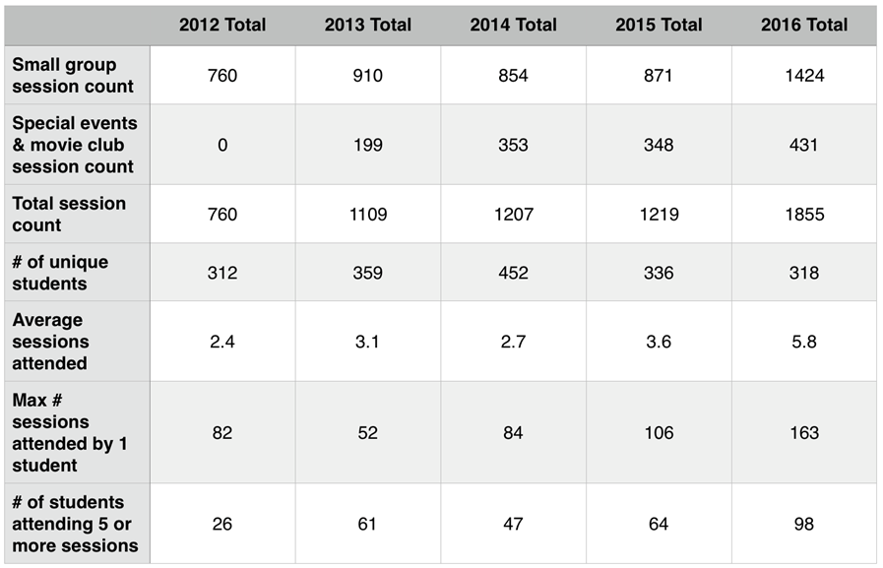
As shown, student participation has increased year by year. A large reason for the 2016 increased level of participation is because members of a 3rd year project learning group that needed to use English while traveling abroad were required to attend twice a week. While the number of unique students attending Connections Cafe has decreased, the students who are attending are participating more frequently. The average number of sessions attended was 5.8 per semester. The strong increase in the number of students who have attended five or more sessions shows that this is not solely the result of a few students with extremely high participation but rather more students coming more often.

Reported by
Andrew Johnson
Adam Smith

4. Professional Development：Workshop on lesson support tools “Basic & useful usage of HOPE / manaba”

Program description
According to the questionnaire with FUN faculty members regarding lesson support tools conducted by the e-learning WG in December, 2016, 16 out of 43 respondents “do not know HOPE” or “know about HOPE, but don’t use it in class”, and 25 gave the same answer regarding manaba. The reason given by those respondents was “I do not know how to use.”

In the light of this situation, the Workshop aims to introduce the participants to the basic operation and useful function for class effectiveness using HOPE and manaba.

Overview of AY 2016-2017 activity
The Workshop was held on Friday, March 24, 2016 from 13:10-16:20 at C&D Room (494).
The schedule is as follows.
13:10-14:00 Introduction: useful function of HOPE（Stuart）
14:00-14:40 Introduction: useful function of manaba（Tominaga）
14:40-14:50 Break
14:50-16:20 Q&A

Outcomes
◆Participants: Ayahiko Niimi, Yo Shiraishi, Asuka Terai, Seiji Takagi, Kei Ito, Yuichi Katori, Kawagishi (Education Affairs Department), and Futatsuka (CISD)

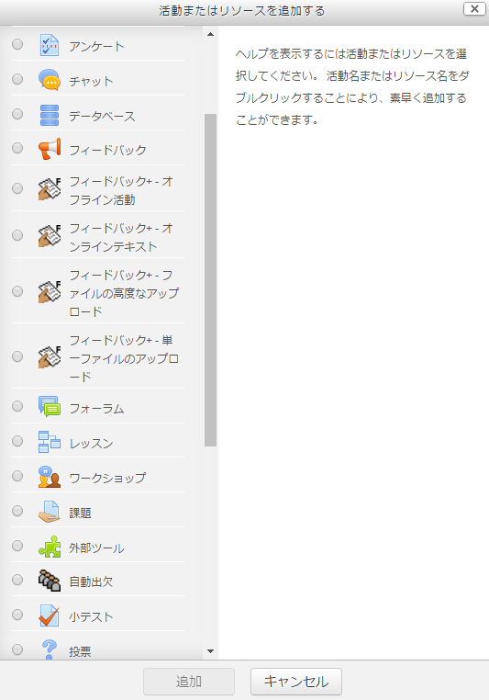
Figure 1 HOPE Activity Module
◆Introduction: useful function of HOPE
Since some participants have not used HOPE at all, we had them have hands-on experience in the course setting and editing.by operating HOPE The workshop also introduced them to the activity module (Figure 1) that enables us to post the class materials and conduct quizzes in class. HOPE has a variety of functions and allows detailed settings. However, this variety may interfere with the beginners to understand the settings. The workshop gave the participants tips about useful functions for class preparations. At the end of the session, the workshop introduced the HOPE users to new features of the most updated version.

◆Introduction: useful function of manaba
In the questionnaire regarding lesson support tools mentioned above, “attendance management” and “quiz provision” are given as recommended functions of manaba. The workshop introduced such functions to the participants with instructional design theory.

Attendance management function: manaba allows to have students answer some simple questions when issuing the attendance card (Figure 2). Students can review the previous class contents with this function. From the perspective of the class development model “the nine instructional events” outlined by Gagne and to enhance retention, time-lagged review is considered to be necessary.

Quiz provision function: From the perspective of active learning, the learner’s activities are classified into “INPUT” of knowledge/skill, “organization/understanding” of knowledge/skill, and “OUTPUT” of the organized/understood knowledge/skill. The lesson style that combines these learner’s activities in increments of 10 – 15 minutes is called “microformats method”. The Workshop introduced the participants to the example of the class conducted with microformats method (Figure 3), in which the quiz provision function is used for organization/understanding of knowledge/skill, and its OUTPUT.

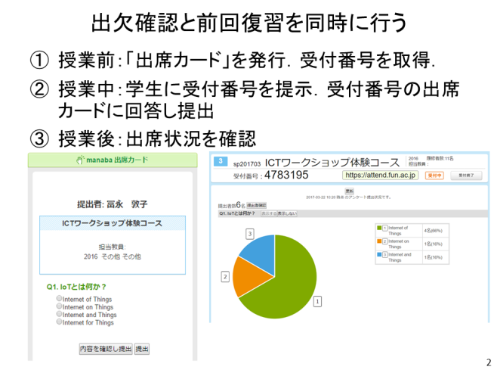  Figure 2 manaba Attendance management | 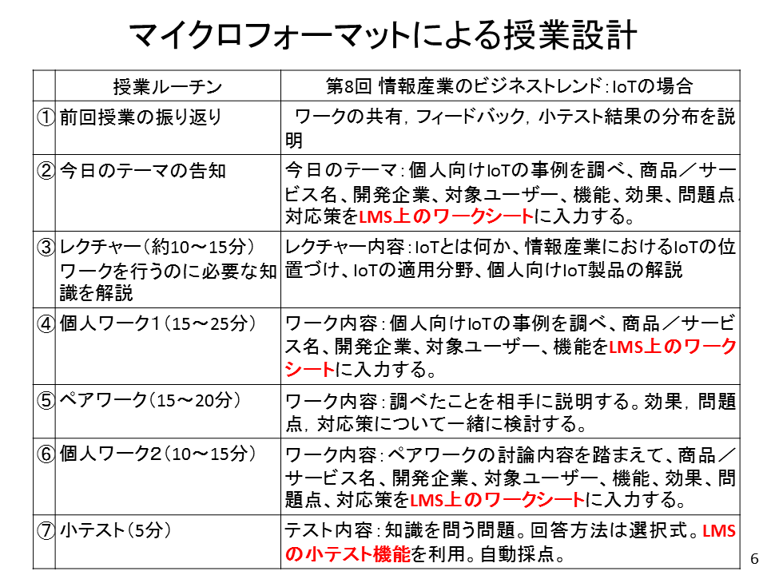  Figure 3 Example of class with microformats method

Reported by
Peter Ruthven-Stuart
Atsuko Tominaga

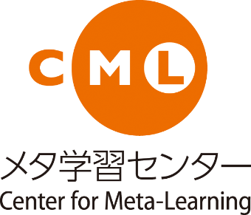

Meaning of CML logo：Double circles represent the relation of “Learning ) Meta-Learning”. Shape of a face or a cup is the images of an open plaza.

Created by Future University Hakodate Center for Meta-Learning
Contact: CML Coordinator cml-coordinator@fun.ac.jp
(March 2017)

